AWS EBS SNAPSHOTS AND DATA LIFECYCLE MANAGER

Amazon Ebs Snapshots : Amazon EBS (Elastic Block Store) snapshots are point-in-time backups of your EBS volumes. They are stored in Amazon S3, according to Amazon Web Services, providing a durable and reliable way to protect your data.

* Backup and Recovery: Snapshots are primarily used to back up EBS volumes and recover data in case of failures, accidental deletion, or data corruption. You can restore a volume or create a new one from an EBS snapshot.
* Disaster Recovery: Snapshots can be copied across regions for disaster recovery and business continuity plans, according to Amazon Web Services.
* Data Migration: EBS snapshots facilitate data migration across Availability Zones (AZs) and regions, according to Amazon Web Services.
* Cost-effectiveness: Since they're incremental, snapshots are a cost-effective way to store backups, as you only pay for the changed blocks, according to Amazon Web Services.
* Security: Snapshots can be encrypted and you can control public access, according to Amazon AWS Documentation.

Elastic Block Store : AWS EBS (Elastic Block Store) is like a virtual hard drive that you can attach to your virtual server (EC2 instance) in Amazon's cloud.

* Volumes
* Snapshots
* Lifecycle Manager

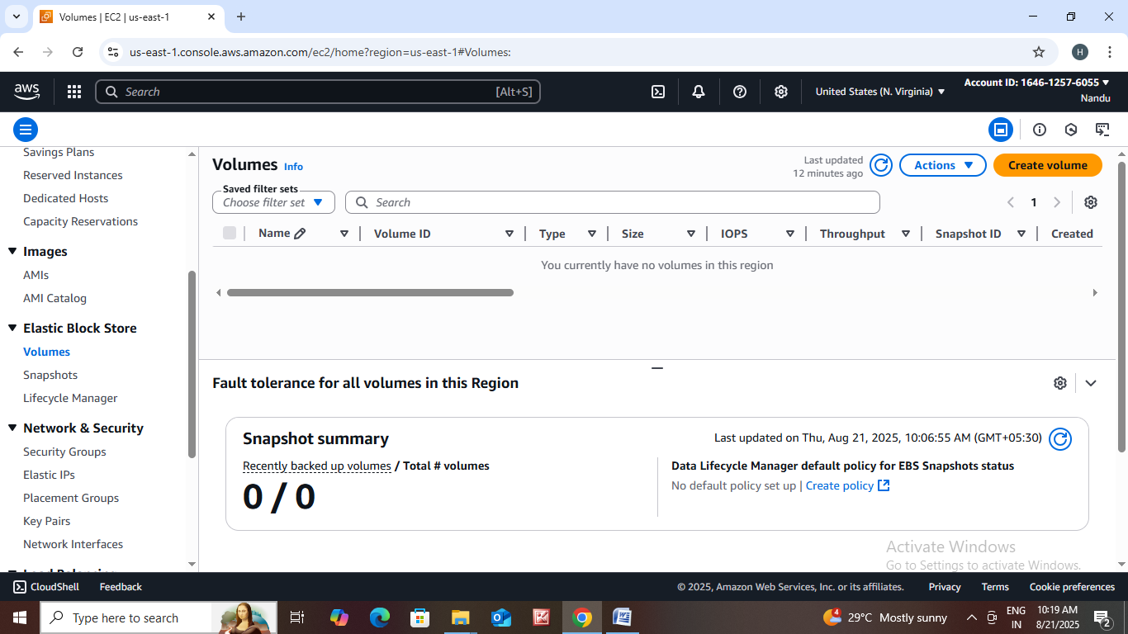How to create volume in EBS?

* Go to <https://aws.amazon.com>.
* Sign into console.
* Click on EC2.
* After that page is open Scroll down then there is an Elastic block store.
* In that Elastic block store we can see volumes.
* Click on volume.

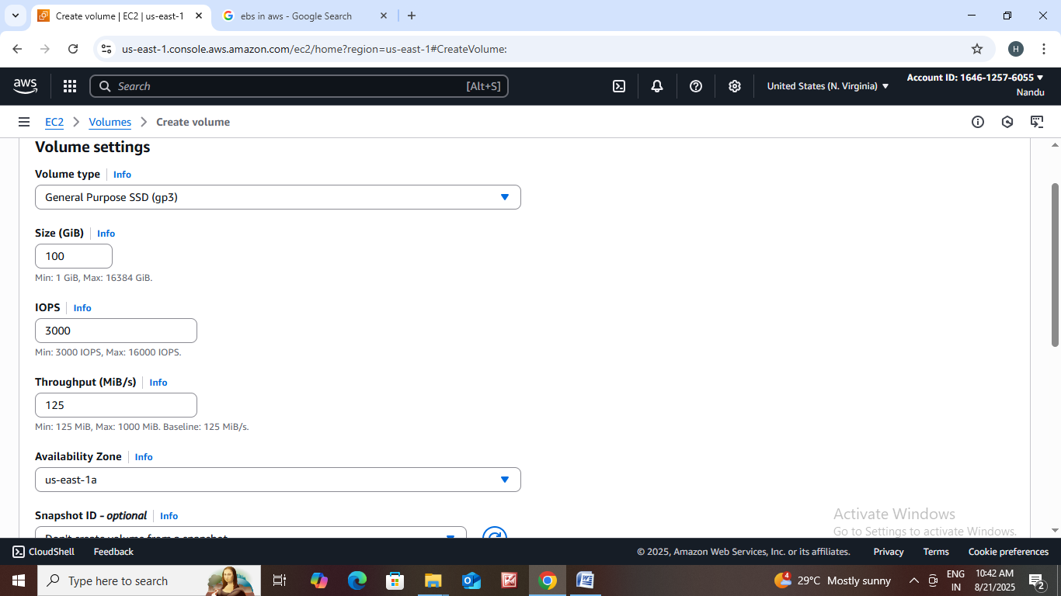

* Volume type :General purpse SSd (GP3) we can choose it.
* Size:100 min-1Gb max-16364 gb
* Iops : we can choose how many iops you want min-3000 Iops max-16000 Iops.
* Throughput : 125 Min :125 MiB Max :1000 MiB Baseline : 125 MiB/s.
* Availability Zone : we can choose which region did you want.
* Snapshot id – optional.
* Tags : we can name the tag like volume1.
* Then click on create volume.

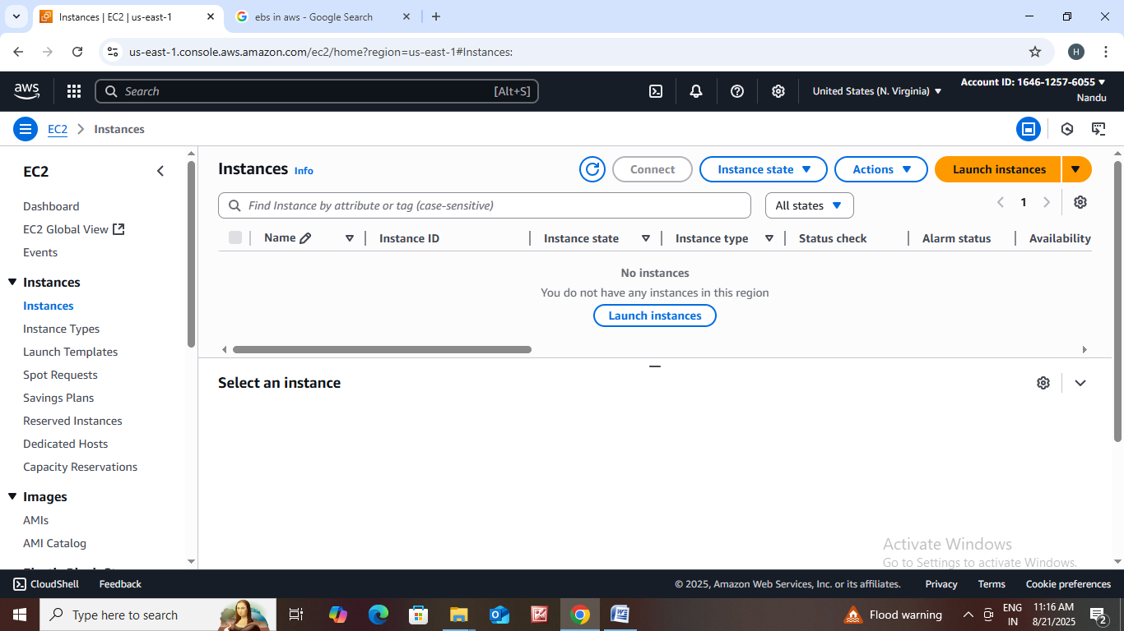How to create EC2 instance?

* Go to <https://aws.amazon.com>.
* Sign into console.
* Click on EC2.
* After that the page is open click on instance.
* Then the instance page is open click on launch instance.
* 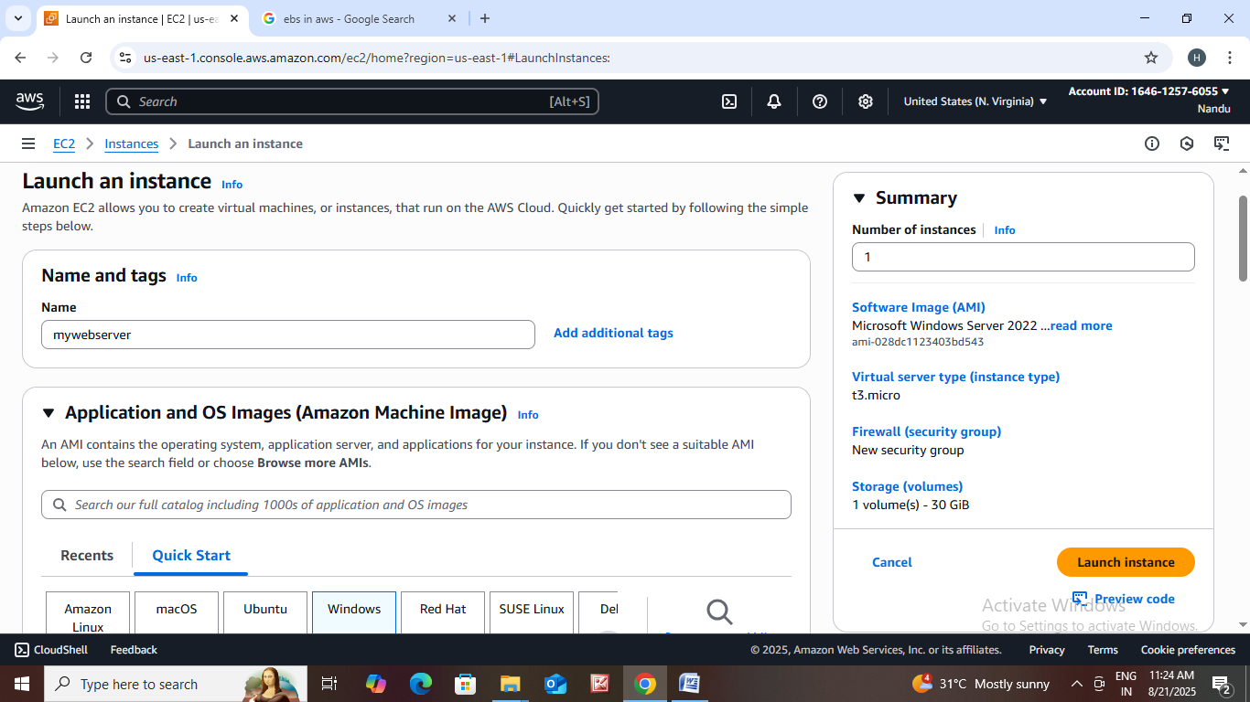Name : mywebppserver
* Amazon machine image : windows
* In windows we can select which type you want.
* Select an instance type which you want.
* Create new key pair Ex : app key.
* Choose configure storage.
* We can edit network settings.
* Then click on launch instance.

* 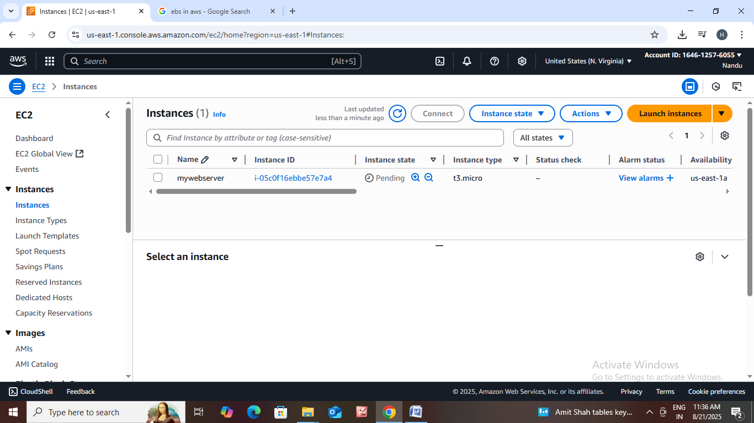Then click on that mywebserver instance id.
* Then the instance summary page is open.
* Then click on connect.
* Then the connect page is open click on RDP client.
* 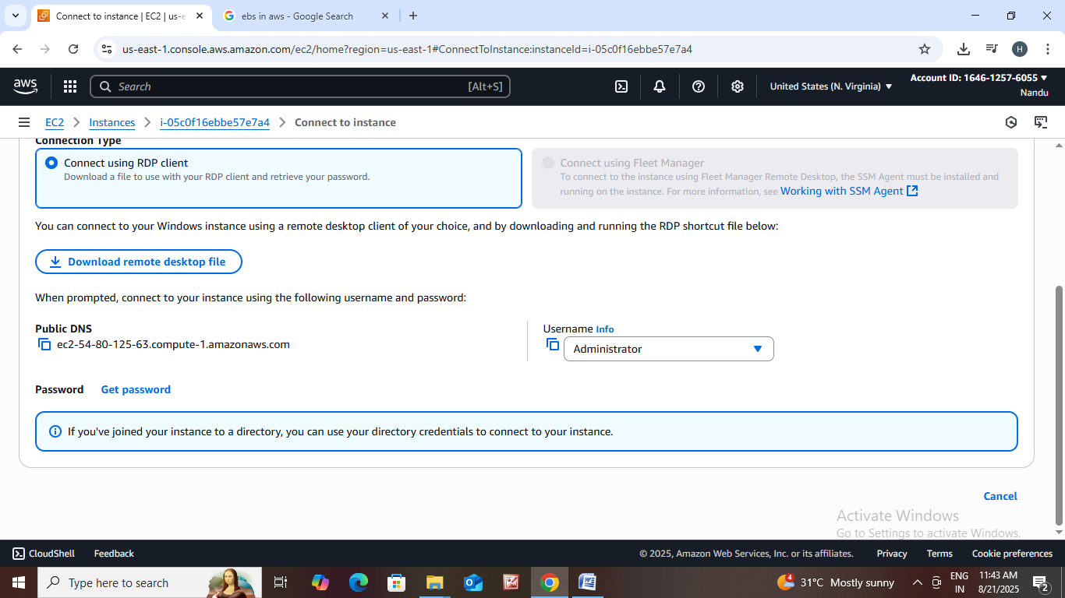Then click on download remote desktop file.
* After downloading is completed.
* Go to files and open that file.
* It asking connect or cancel press connect.
* After that it asking password.
* In Rdp client page scroll down we can see get password.
* Click on that get password.
* Get windows page is open then click on upload private key file.
* Upload that appkey on it and click on decrypt password.
* 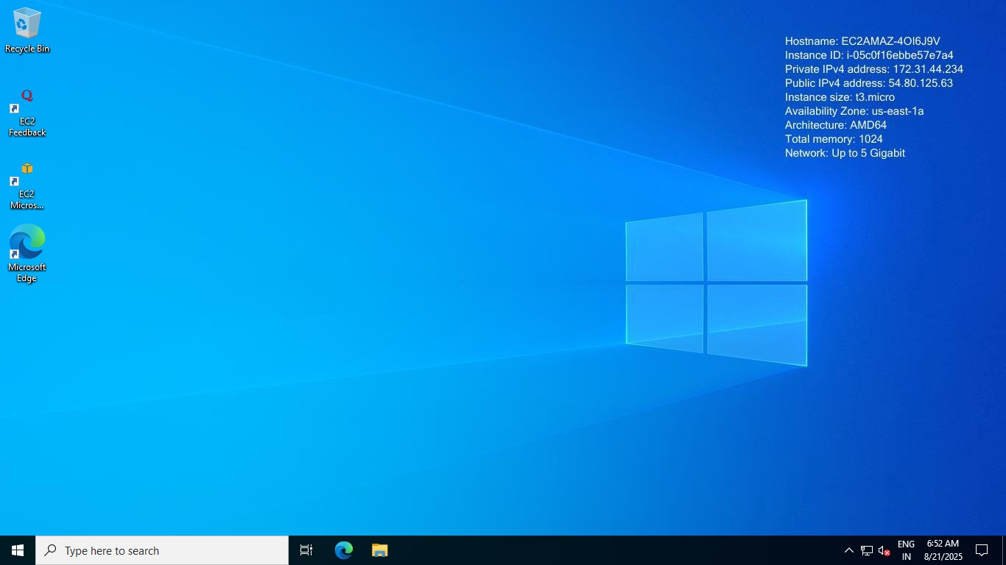The rdp client page is open automatically the password is available in that page copy that password and paste it on where that password is asking.
* Then that server page is open.

Using Volume how to create Snapshot?

* Go to instance page scroll down we can see options click on storage.
* We can see volume click on that volume id.
* The volume id page is open scroll down then click on manage tags.
* Then manage tag info page is open then click on add tags. Name that tag and save it.
* 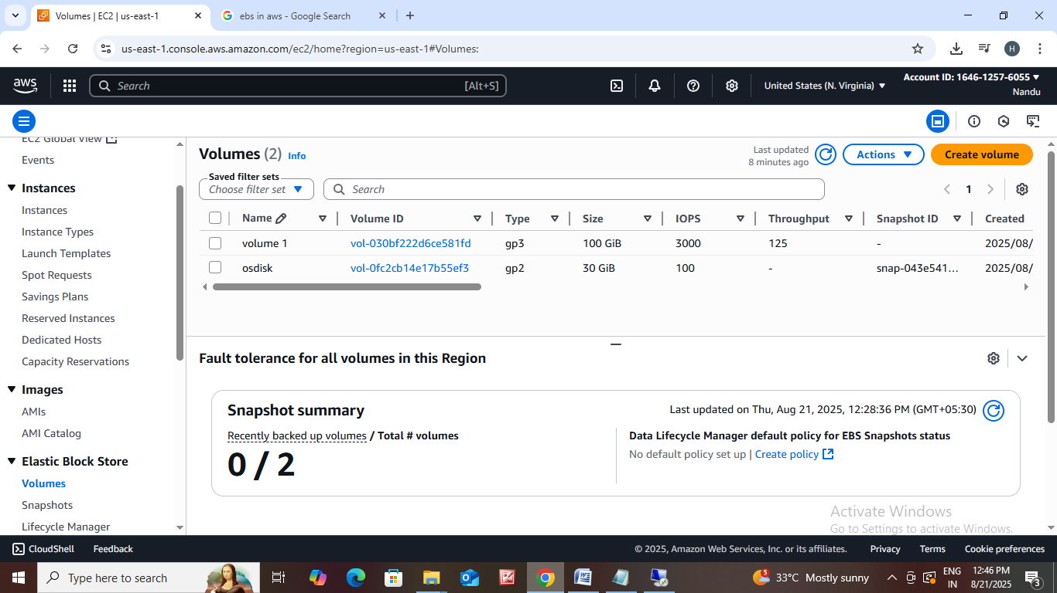Select that volume and click on actions.
* In that actions we can see create snapshot click on it.
* In that snapshot details: \*Description : Os disk snapshot \*Add tag : Os disk snapshot.
* Then click on create snapshot.
* In that EBS under snapshot is there we can click that snapshot we can see that snapshot.

How to create image and how to create Volume using snapshot?

* 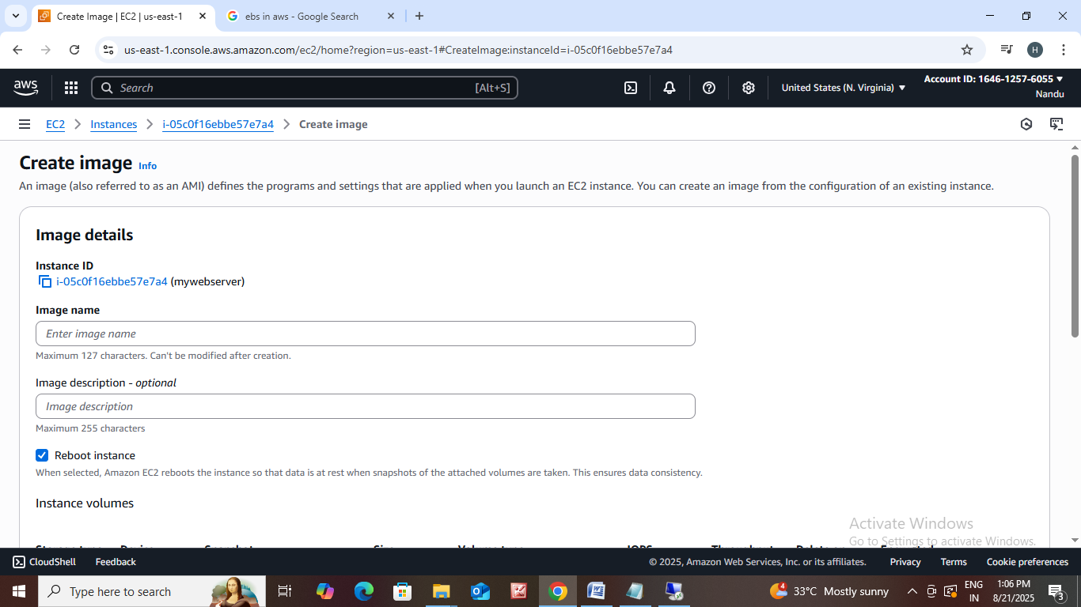Go to instance click on actions we can see options click on image and template.
* Then click on create image.
* Enter image name : myappimage.
* Enter image description : devenv.
* Then click on create image.
* Go to AMI we can see image.
* Go to snapshots click on actions.
* After that click on create volume from snapshot.
* Then enter the details in it then click on create volume.